Canopy Hinge Design

Solar Gators Car Canopy Hinge
As a member at Solar Gators, a solar racing vehicle design team, I was tasked with a canopy hinge design. The hinge would attach the canopy to the solar collector of the vehicle, referred to as the ‘top body’, and would let the canopy pivot up and down. The design consists of a base attached to the underside of the top body, a mount that will hold the base and two J-arms, and a rod clamping system to attach the arms to the canopy. The arc of the J-arms was calculated so that the edge of the canopy wouldn’t interfere with the top body when being lifted (Figure 1). A gas spring will also be implemented so that the canopy doesn’t fall on the driver when exiting the car.

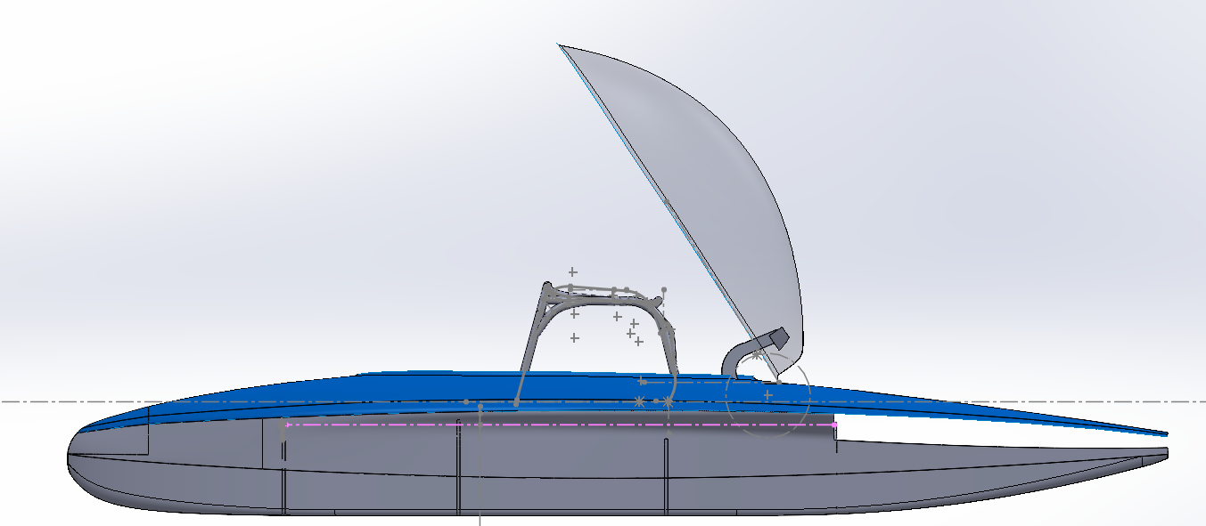
Fig. 1. Open canopy, full car side view.
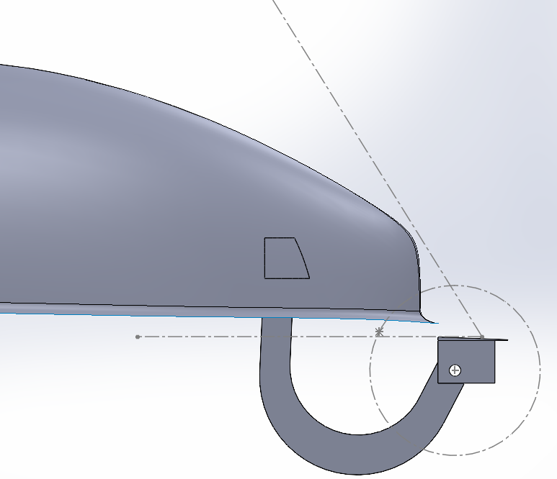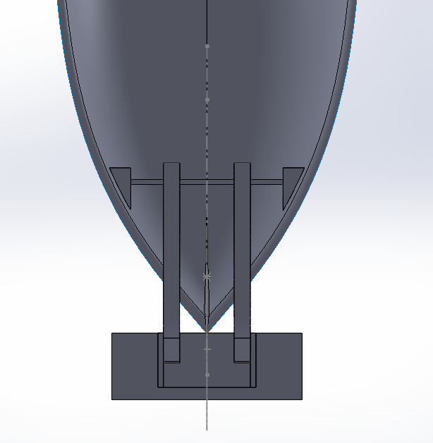
Fig. 2. Left image shows side view of the system, right image shows the bottom view of the attachment.

